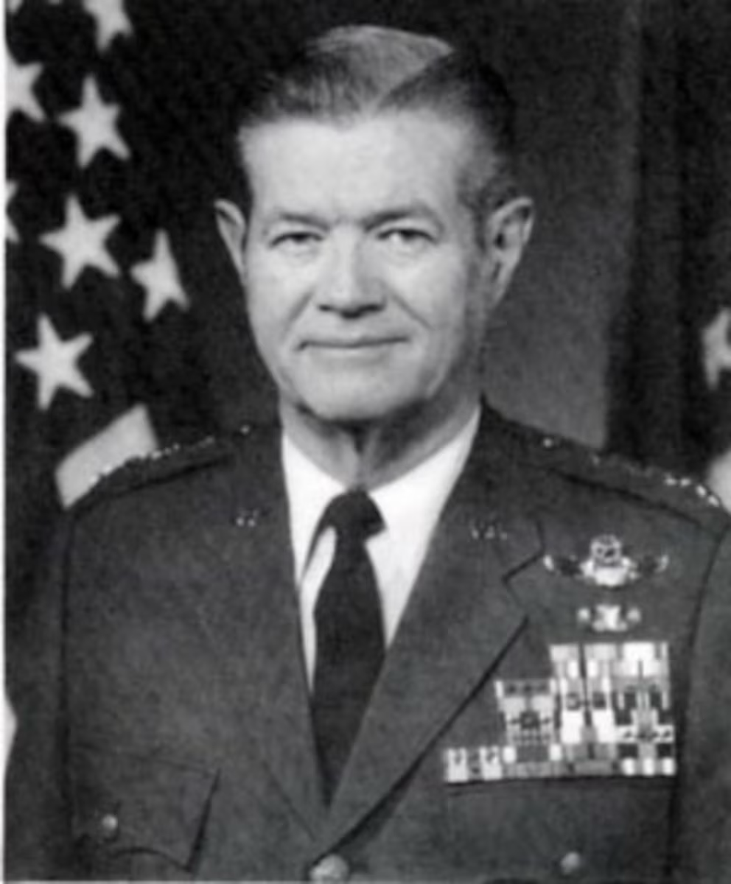

GENERAL MICHAEL P.C. CARNS
General Michael P.C. Carns is vice chief of staff, Headquarters U.S. Air Force, Washington, D.C.
General Carns was born in Junction City, Kan., in 1937, and graduated from St. John's High School, Washington, D.C., in 1955. He earned a bachelor of science degree from the U.S. Air Force Academy in 1959 and a master's degree in business administration from Harvard University in 1967. The general completed Squadron Officer School in 1963 and the Royal College of Defence Studies, London, in 1977.
He was commissioned as a second lieutenant upon graduation from the academy. He completed primary pilot training in March 1960 at Graham Air Base, Fla., and basic pilot training at Laredo Air Force Base, Texas, in September 1960. After pilot instructor training at Randolph Air Force Base, Texas, General Carns returned to Laredo, where he served as a flight instructor. From December 1961 until June 1962 he was aide to the commander, Air Reserve Records Center, Denver. He then served as aide to the commander, 4th Air Force Reserve Region, Randolph, until July 1963, when he began a two-year tour of duty as an air operations officer there.
After graduation from Harvard University in 1967, General Carns was assigned to the 476th Tactical Fighter Squadron, George Air Force Base, Calif., flying F-4s. In January 1968 he transferred to the 40th Tactical Fighter Squadron, Eglin Air Force Base, Fla., again flying F-4s. From August 1968 to September 1969 he was assigned to the 469th Tactical Fighter Squadron, Korat Royal Thai Air Force Base, Thailand, where he flew 200 combat missions in the F-4E.
Upon his return to the United States in September 1969, he was assigned as a plans and programs officer with the Air Staff, Air Force headquarters. He later was aide to the Air Force chief of staff.
From September 1973 to May 1975 General Carns commanded the 613th Tactical Fighter Squadron, 401st Tactical Fighter Wing, Torrejon Air Base, Spain. He then was assigned for almost two years as special assistant to the chief of staff, Supreme Allied Commander Europe, Supreme Headquarters Allied Powers Europe, Mons, Belgium. After completing the Royal College of Defence Studies, the general was assigned to the 81st Tactical Fighter Wing, Royal Air Force Station Bentwaters, England, as deputy commander for operations.
He returned to the United States in March 1979 and took command of the 354th Tactical Fighter Wing, Myrtle Beach Air Force Base, S.C. The general moved to Nellis Air Force Base, Nev., in October 1980 as commander of the 57th Fighter Weapons Wing. In June 1982 he became director of operations, J-3, Rapid Deployment Joint Task Force, later redesignated U.S. Central Command, MacDill Air Force Base, Fla. He became deputy chief of staff for plans, Headquarters Pacific Air Forces, Hickam Air Force Base, Hawaii, in July 1984, and deputy chief of staff for operations and intelligence in June 1985. In July 1986 he assumed command of 13th Air Force, Clark Air Base, Philippines. In June 1987 he was assigned as deputy commander in chief and chief of staff, U.S. Pacific Command, Camp H.M. Smith, Hawaii. He became director, the Joint Staff, Washington, D.C., in September 1989. He assumed his present position in May 1991.
The general is a command pilot with more than 6,400 flying hours. His military awards and decorations include the Defense Distinguished Service Medal with oak leaf cluster, Distinguished Service Medal, Silver Star, Defense Superior Service Medal, Legion of Merit with three oak leaf clusters, Distinguished Flying Cross, Air Medal with 10 oak leaf clusters, Air Force Commendation Medal and the Government of the Philippines Outstanding Achievement Medal.
He was promoted to general May 16, 1991, with same date of rank.
(Current as of April 1994)

